**HandsMen Threads: Elevating the Art of Sophistication in Men's Fashion**

**Project Overview**

HandsMen Threads, a premium men's fashion brand, aims to leverage Salesforce to streamline operations, enhance customer experience, and optimize inventory management. This project focuses on implementing Salesforce CRM to manage customer orders, track inventory, automate marketing campaigns, and provide seamless customer service.

**Objectives**

HandsMen Threads, a dynamic organization in the fashion industry, is embarking on a Salesforce project designed to revolutionize their data management and enhance customer relations.

The project involves building a robust data model tailored to store all pertinent business data, ensuring a seamless flow of information across the organization.

A key aspect of this project is the maintenance of data integrity directly from the user interface (UI). This feature will safeguard the accuracy and consistency of the data, which is crucial for informed decision-making and reliable business operations. The project will integrate several new processes into the business workflow to improve customer service and operational efficiency:

* Automated Order Confirmations: Post-order confirmation, customers will receive an email update, fostering engagement and strengthening customer relations.
* Dynamic Loyalty Program: Customer loyalty statuses will be updated based on purchase history, enabling personalized rewards and promoting repeat business.
* Proactive Stock Alerts: When stock levels drop below five units, automatic emails will notify the warehouse team, ensuring timely restocking and preventing stockouts.
* Scheduled Bulk Order Updates: Daily midnight, the system will process bulk orders, updating financial records and adjusting inventory, ensuring accurate stock levels for daily operations.

**Phase 1:**

**Requirement Analysis & Planning**

Use Case :

Developing a premium fashion platform to streamline men’s bespoke tailoring and enhance customer experience through personalized styling and seamless order management.

Instructions:

1. Salesforce CRM Implementation
2. Process Automation & Workflows
3. Apex & Trigger Implementations
4. Batch Jobs & Scheduled Processes
5. Data Security & Access Control

**Phase 2:**

**Salesforce Development - Backend & Configurations**

Setup environment & DevOps workflow:

1. Creating Developer Account
2. Creating a developer org in salesforce.
3. Account Activation

App, Object and field creation:

1. The following are the Custom objects which we created
   * HandsMen Customer
   * HandsMen Order
   * HandsMen Product
   * Inventory
   * Marketing Campaign
2. Data Management Tabs Creation for each object
3. Creation in Salesforce Platform
4. The following are the fields that we created in objects:
   * 1. HandsMen Customer:
     + First Name
     + Last Name
     + Email (Email),
     + Phone (Phone),
     + Loyalty Status (Picklist: Bronze, Gold, Silver)
     + Total Purchases (Number)
     1. HandsMen Product:
     + Name (Record Name),
     + SKU ( Text ),
     + Price (Currency),
     + Stock\_Quantity\_\_c (Number)
     1. HandsMen Order:
     + Order\_Number (Record Name),
     + Status (Picklist: Pending, Confirmed, Rejection),
     + Quantity\_\_c (Number),
     + Total\_Amount\_\_c(Number)
     1. Inventory:
     + Auto Number (Record Name),
     + Warehouse (Text),
     + Stock\_Quantity\_\_c (Number)
     1. Marketing Campaigns:
     + Campaign\_Name (Record Name),
     + Start\_Date (Date),
     + End\_Date (Date)
5. Formula Fields:

* FullName (HandsMen Customer)

*Formula : FirstName & " " & LastName*

* Stock Status (Inventory)

*Formula : IF(Stock\_Quantity\_\_c > 10, "Available", "Low Stock")*

1. Lookup Relations:
   * Marketing Campaign and HandsMen Customer
   * HandsMen Product and HandsMen Order
   * HandsMen Order and HandsMen Customer
2. Master-Detail Relationship:
   * Inventory and HandsMen Product

Validation Rules :

|  |  |  |  |
| --- | --- | --- | --- |
| S no. | **Object** | **Field** | **Validation Rule** |
| **1.** | HandsMen Order | Total Amount | Total\_Amount\_\_c <= 0 |
| **2.** | Inventory | Stock Quantity | Stock\_Quantity\_\_c < = 0 |
| **3.** | HandsMen Customer | Email | NOT CONTAINS(Email, "@[gmail.com](http://gmail.com/" \t "_blank)") |

Flows :

|  |  |  |  |
| --- | --- | --- | --- |
| **Sno.** | **Flow Name** | **Type** | **Trigger Condition** |
| 1. | Order Confirmation Email | Record-Triggered | Trigger: When a record is updated  Condition: Order\_\_c.Status\_\_c = "Confirmed" |
| 2. | Stock Alert Email | Record-Triggered | Trigger: When a record is created or updated  Condition: Stock\_Quantity\_\_c < 5 |
| 3. | Loyalty Status Update | Schedule-Triggered Flow | Trigger: Runs Daily  Condition : to update Loyality\_Status\_c |

**Phase 3:**

**UI/UX Development & Customization**

1.Data Security Profiles Creation :

* “Platform 1”

2.Data Security Roles Creation :

* Sales
* Marketing
* Inventory

3.Data Security User Creation :

Users for the three security roles

* Sales : Niklaus Mikaelson
* Marketing : Dinese Wheeler
* Inventory : Kol Mikaelson

4.Email Template:

Creating the following email templates:

|  |  |  |
| --- | --- | --- |
| **Template Name** | ***Type*** | **Trigger** |
| Order Confirmation | *HTML* | Sent when Order is placed |
| Low Stock Alert | *Text* | Sent when Inventory\_\_c.Stock\_Quantity\_\_c < 5 |
| Loyalty Program Email | *HTML* | Sent when customer qualifies for loyalty rewards |

**Order Confirmation Email Template:-**

*Dear {!HandsMen\_Order\_\_c.HandsMen\_Customer\_\_c},*

*Your order #{!HandsMen\_Order\_\_c.Name} has been confirmed!*

*Thank you for shopping with us.*

*Best Regards,*

*Sales Team*

**Low Stock Alert Email Template:-**

*Dear Inventory Manager,*

*This is to inform you that the stock for the following product is running low:*

*Product Name: {!Inventory\_\_c.HandsMen\_Product\_\_c}*

*Current Stock Quantity: {!Inventory\_\_c.Stock\_Quantity\_\_c}*

*Please take the necessary steps to restock this item immediately.*

*Best Regards,*

*Inventory Monitoring System*

**Loyality Points Email Template:-**

*Congratulations! You are now a {!HandsMen\_Customer\_\_c.Loyalty\_Status\_\_c} member and you are eligible for our Loyalty Rewards Program.*

*Enjoy exclusive discounts, early access to offers, and special member benefits.*

*Thank you for your continued Support.*

**Phase 4:**

**Data Migration, Testing & Security**

Data Security - Permission Set :

|  |  |  |
| --- | --- | --- |
| **S no.** | **Role** | **Access Level** |
| **1.** | Sales Manager | Full Access to Customers, Orders |
| **2.** | Inventory Manager | Read & Edit on Inventory, Products |
| **3.** | Marketing Team | Read on Customers, Edit on Marketing Campaigns |

Automation using Apex

Apex Triggers

|  |  |  |
| --- | --- | --- |
| **Trigger Name** | **Object** | **Purpose** |
| **Update Order Total** | Order\_\_c | Auto-update Total\_Amount\_\_c on order save |
| **Stock Deduction** | Inventory\_\_c | Reduce stock when an order is placed |
| **Loyalty Status Update** | Customer\_\_c | Upgrade loyalty status based on purchases |

**Update Order Total :-**

*trigger OrderTotalTrigger on HandsMen\_Order\_\_c (before insert, before update) {*

*Set<Id> productIds = new Set<Id>();*

*for (HandsMen\_Order\_\_c order : Trigger.new) {*

*if (order.HandsMen\_Product\_\_c != null) {*

*productIds.add(order.HandsMen\_Product\_\_c);*

*}*

*}*

*Map<Id, HandsMen\_Product\_\_c> productMap = new Map<Id, HandsMen\_Product\_\_c>(*

*[SELECT Id, Price\_\_c FROM HandsMen\_Product\_\_c WHERE Id IN :productIds]*

*);*

*for (HandsMen\_Order\_\_c order : Trigger.new) {*

*if (order.HandsMen\_Product\_\_c != null && productMap.containsKey(order.HandsMen\_Product\_\_c)) {*

*HandsMen\_Product\_\_c product = productMap.get(order.HandsMen\_Product\_\_c);*

*if (order.Quantity\_\_c != null) {*

*order.Total\_Amount\_\_c = order.Quantity\_\_c \* product.Price\_\_c;*

*}*

*}*

*}*

*}*

**Stock Deduction Trigger:-**

*trigger StockDeductionTrigger on HandsMen\_Order\_\_c (after insert, after update) {*

*Set<Id> productIds = new Set<Id>();*

*for (HandsMen\_Order\_\_c order : Trigger.new) {*

*if (order.Status\_\_c == 'Confirmed' && order.HandsMen\_Product\_\_c != null) {*

*productIds.add(order.HandsMen\_Product\_\_c);*

*}*

*}*

*if (productIds.isEmpty()) return;*

*// Query related inventories based on product*

*Map<Id, Inventory\_\_c> inventoryMap = new Map<Id, Inventory\_\_c>(*

*[SELECT Id, Stock\_Quantity\_\_c, HandsMen\_Product\_\_c*

*FROM Inventory\_\_c*

*WHERE HandsMen\_Product\_\_c IN :productIds]*

*);*

*List<Inventory\_\_c> inventoriesToUpdate = new List<Inventory\_\_c>();*

*for (HandsMen\_Order\_\_c order : Trigger.new) {*

*if (order.Status\_\_c == 'Confirmed' && order.HandsMen\_Product\_\_c != null) {*

*for (Inventory\_\_c inv : inventoryMap.values()) {*

*if (inv.HandsMen\_Product\_\_c == order.HandsMen\_Product\_\_c) {*

*inv.Stock\_Quantity\_\_c -= order.Quantity\_\_c;*

*inventoriesToUpdate.add(inv);*

*break;*

*}*

*}*

*}*

*}*

*if (!inventoriesToUpdate.isEmpty()) {*

*update inventoriesToUpdate;*

*}*

*}*

Batch Jobs:

**Description**

|  |  |  |
| --- | --- | --- |
| **Batch Job** | **Purpose** | **Schedule** |
| Loyalty Points Calculation | Updates customer points weekly | Every Sunday 12 AM |
| Inventory Sync | Syncs stock levels with external warehouse system | Daily at 2 AM |

**Source Code:**

*global class InventoryBatchJob implements Database.Batchable<SObject>, Schedulable {*

*global Database.QueryLocator start(Database.BatchableContext BC) {*

*return Database.getQueryLocator(*

*'SELECT Id, Stock\_Quantity\_\_c FROM Product\_\_c WHERE Stock\_Quantity\_\_c < 10'*

*);*

*}*

*global void execute(Database.BatchableContext BC, List<SObject> records) {*

*List<HandsMen\_Product\_\_c> productsToUpdate = new List<HandsMen\_Product\_\_c>();*

*// Cast SObject list to Product\_\_c list*

*for (SObject record : records) {*

*HandsMen\_Product\_\_c product = (HandsMen\_Product\_\_c) record;*

*product.Stock\_Quantity\_\_c += 50; // Restock logic*

*productsToUpdate.add(product);*

*}*

*if (!productsToUpdate.isEmpty()) {*

*try {*

*update productsToUpdate;*

*} catch (DmlException e) {*

*System.debug('Error updating inventory: ' + e.getMessage());*

*}*

*}*

*}*

*global void finish(Database.BatchableContext BC) {*

*System.debug('Inventory Sync Completed');*

*}*

*// Scheduler Method*

*global void execute(SchedulableContext SC) {*

*InventoryBatchJob batchJob = new InventoryBatchJob();*

*Database.executeBatch(batchJob, 200);*

*}*

*}*

**Execute anonymous window code:-**

*System.schedule('Daily Inventory Sync', '0 0 0 \* \* ?', new InventoryBatchJob());*

**Phase 5:**

**Deployment, Documentation & Maintenance**

Screenshots:-

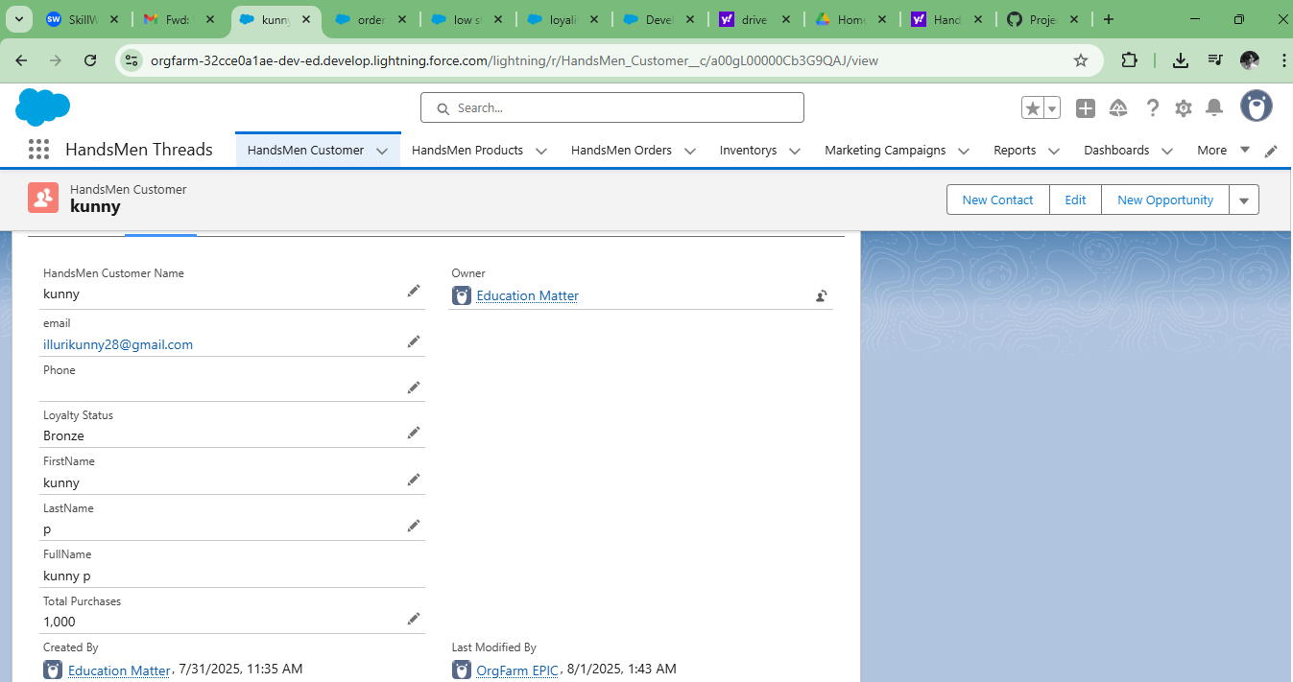

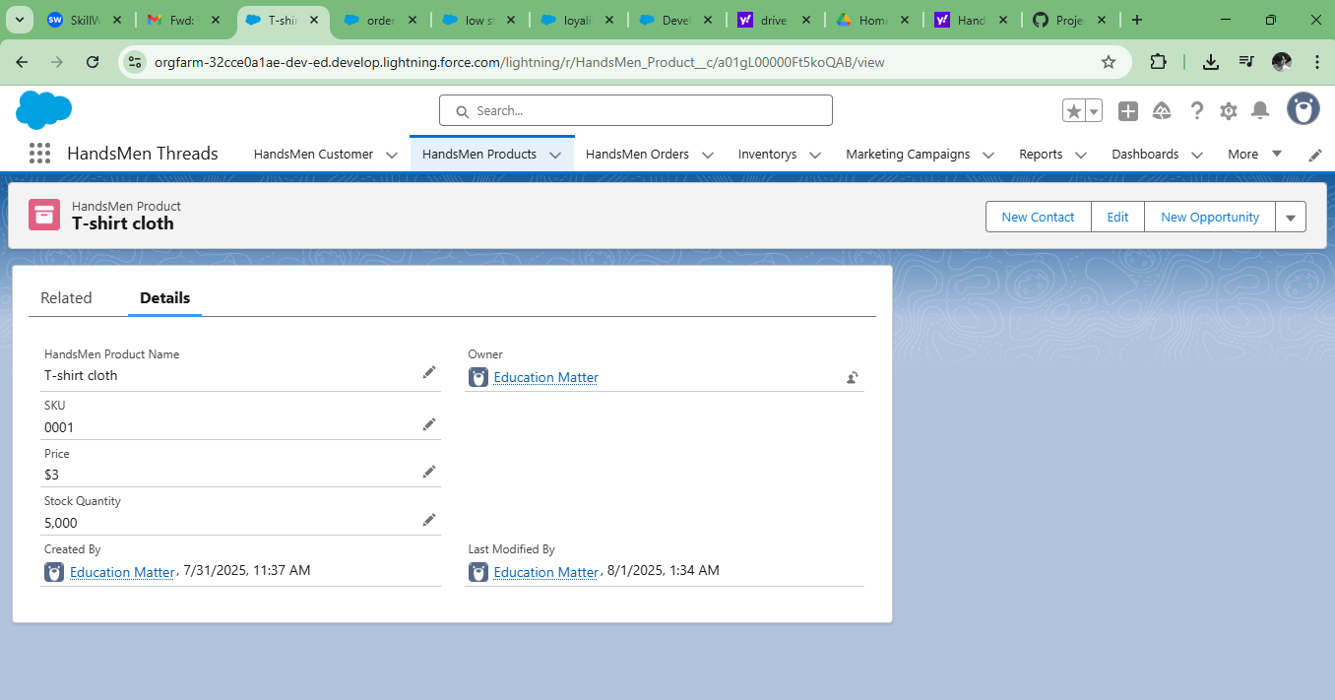

**Conclusion**

HandsMen Threads, a premium men's fashion brand, aims to leverage Salesforce to streamline operations, enhance customer experience, and optimize inventory management. This project focuses on implementing Salesforce CRM to manage customer orders, track inventory, automate marketing campaigns, and provide seamless customer service.

The project involves building a robust data model tailored to store all pertinent business data, ensuring a seamless flow of information across the organization.

A key aspect of this project is the maintenance of data integrity directly from the user interface (UI). This feature will safeguard the accuracy and consistency of the data, which is crucial for informed decision-making and reliable business operations.The project will integrate several new processes into the business workflow to improve customer service and operational efficiency